Supplementary Information

Ultrasensitive and selective non-enzymatic glucose detection based on pt electrode modified by carbon nanotubes@graphene oxide/ nickel hydroxide-Nafion hybrid composite in alkaline media
Alireza Taheri^{a,}*, Sirous Mohammadiª, Zeinab Rezayati-zad^{b}
a Islamic Azad University- Ilam, Branch, Ilam, Iran
b Department of Food and Drug, Faculty of Medicine, Ilam University of Medical Sciences, Ilam, Iran

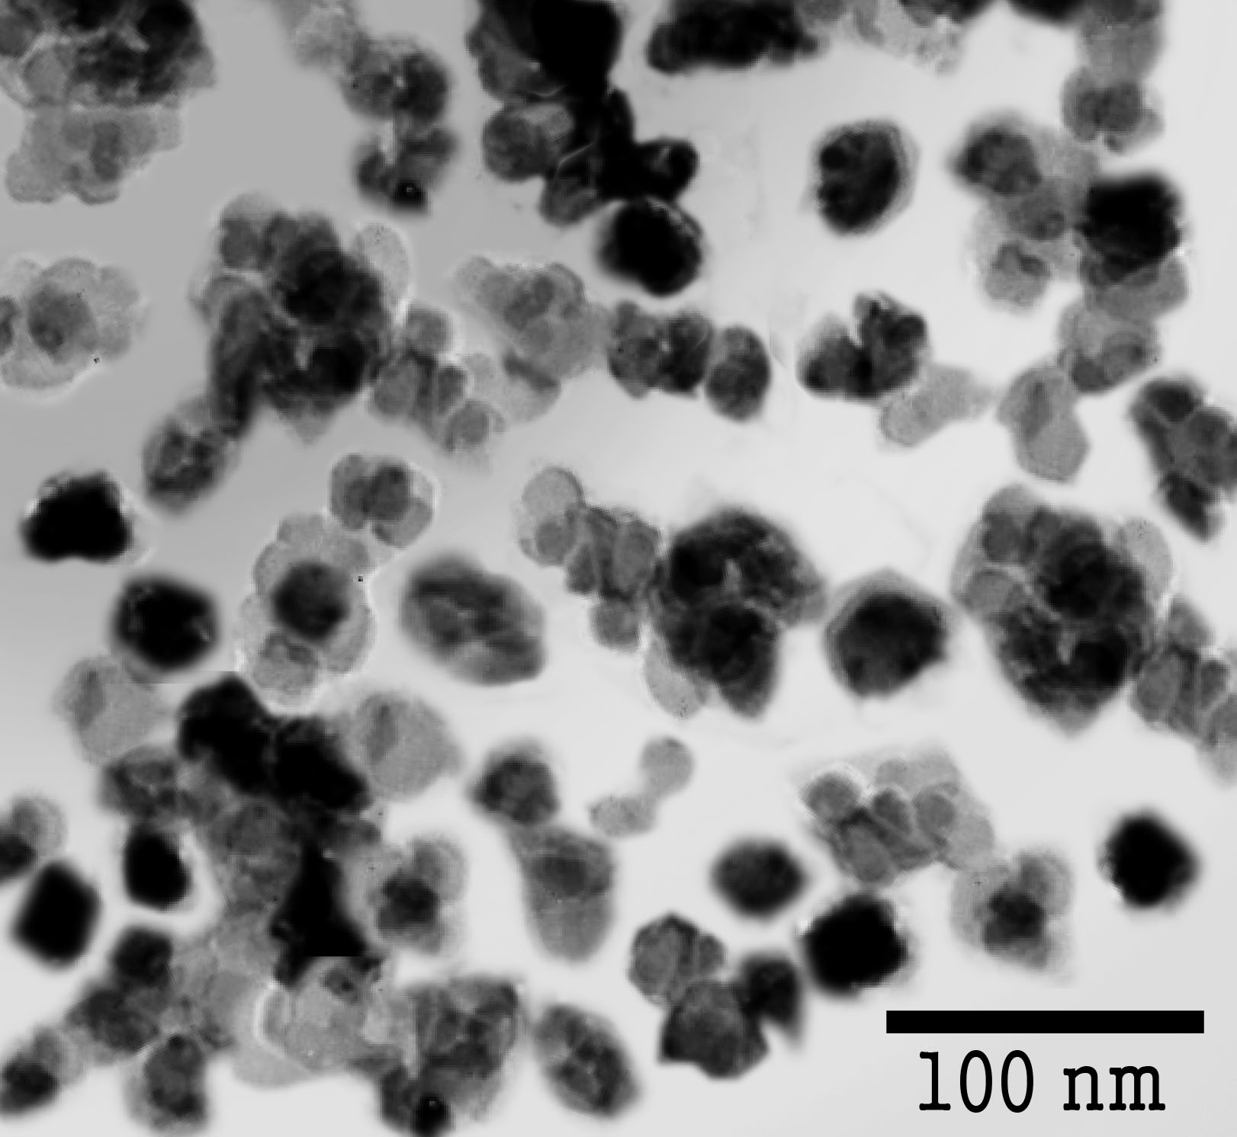
Fig. 1. TEM image of nickel hydroxide powders.

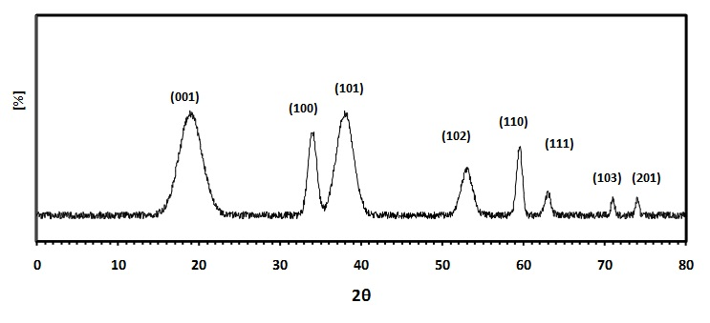
Fig. 2. Typical X-ray diffraction patterns of Ni(OH)₂ nanoscale.

