Supporting Information
Sr. No. | Contents | Page No.
 | Material and Method | 02
 | XRF analysis data of Mangifera Indica L. kachchh region | 03
 | Graph of XRF for mineral ion in the leaves of Mangifera Indica L. kachchh region | 04
 | XRF analysis data of Mangifera Indica L. Saurashtra region | 05
 | Graph of XRF for mineral ion in the leaves of Mangifera Indica L. Saurashtra region | 06
Materials and Methods:
Sample preparation:
Leaves of Mangifera Indica L. were collected in Kachchh and Saurashtra region of Gujarat in November December 2020. The leaves were sun dried to evaporate the water content from them. After then it was grounded in mixture and with the help of pellet maker. Pellets from leaf samples were used for further elemental analysis in on-instrument energy dispersive X-ray fluorescence.
Instrumental parameters:
Rigaku elemental analyzer are benchtop X-ray fluorescence (XRF) with element range Na to U with Pd anode X-ray tube with high performance SDD detector using NEX CG software.
XRF analysis Method:
Operational sequence is blunging (de-aggregation), screening (coarse de-gritting) with 325 ASTM mesh, filtration and drying (with laboratory oven). The washed powder was again slurried in water (10% solid) for testing pH of the slurry. Loss on ignition was determined using muffle furnace at 1000°C. Major oxides showed in Table 1 and 2 were tested using X-ray fluorescence (XRF). Samples were dried 10 to 100 °C for 1 hrs, then pressed into pellets for performed XRF with Rigaku NEX DE, with He-flush rat 12 W, 60 kV X-ray tube.

XRF analysis data of Mangifera Indica L. kachchh region
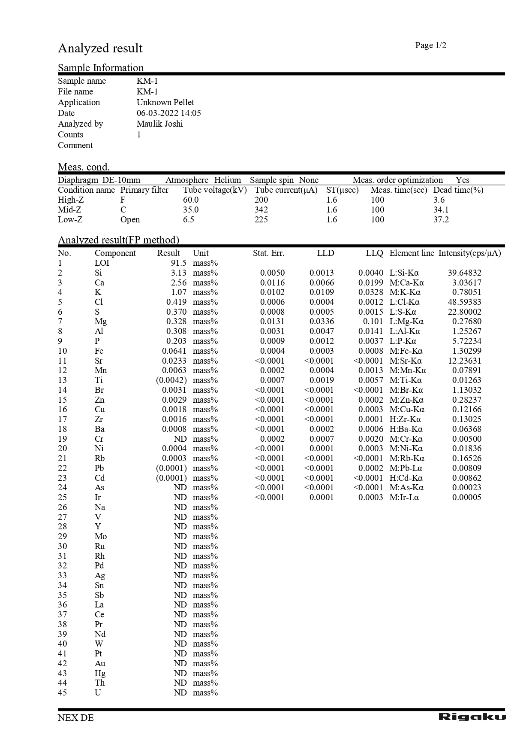
Graph of XRF for mineral ion in the leaves of Mangifera Indica L. kachchh region
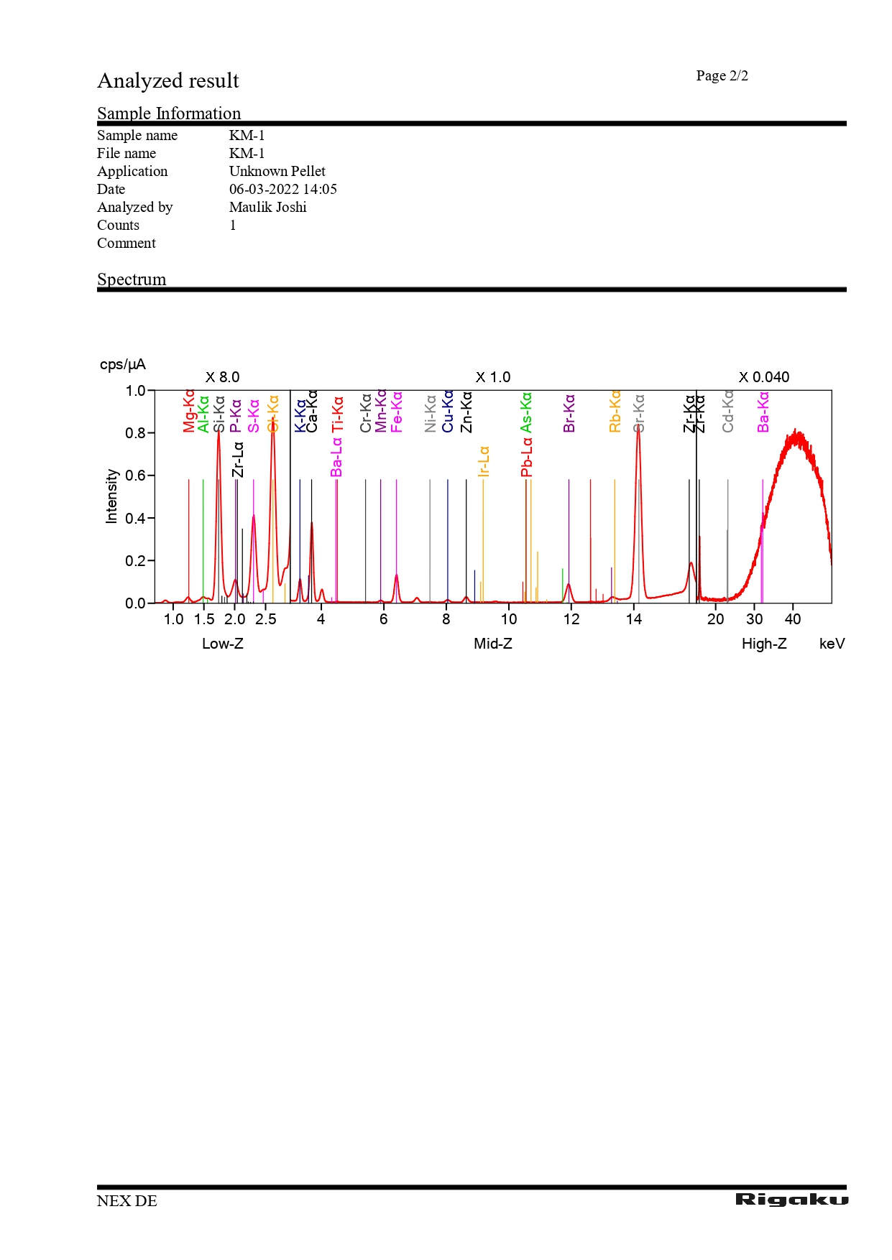
XRF analysis data of Mangifera Indica L. Saurashtra region
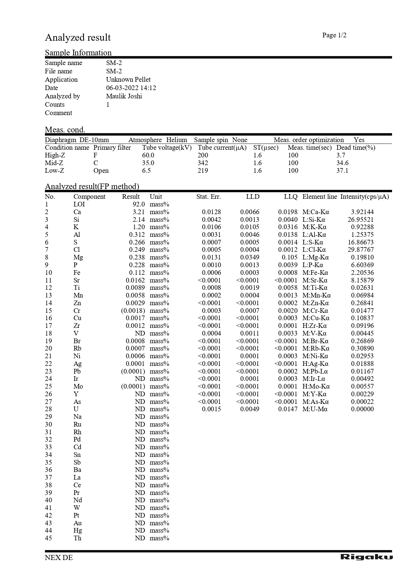
Graph of XRF for mineral ion in the leaves of Mangifera Indica L. Saurashtra region 