Supplementary material for:

A Simple Specific Dopamine Aptasensor Based on Partially Reduced Graphene Oxide–AuNPs composite
Hamideh Roshanfekr*^{1,2}
¹Department of Chemistry, Ilam branch, Islamic Azad University, Ilam, Iran
²Arta Shimi Alborz Research Center, Tehran, Iran

*Corresponding author’s e-mail: roshanfekrhamide@gmail.com
Tel/Fax: +988432228074

2.4. Gold nanoparticles synthesis and making its composite with PRGO
Colloidal AuNPs yield based on the procedures reported previously (21). Briefly, defined volumes of HAuCl₄·3H₂O (0.01% wt.) and sodium citrate solution (1% wt.) as a reducing agent reacted to each other (50 and 0.5 ml). The obtained stable colloid was kept in a dark glass bottle at 4 °C. In next step the PRGO–AuNPs composite was prepared by mixing the stable dispersion of AuNPs and PRGO colloid (0.5 mg ml⁻¹) and shaking for 8-12 h. the shaking causes the intercalation of gold nanoparticles between PRGO sheets. The weight ratio of AuNPs to PRGO should be 1.

2.4. Fabrication steps of Aptamer/AMP/ PRGO–AuNP /GCE aptasensor
First, a GC electrode was polished with alumina powder, washed with water, sonicated in ethanol and double-distilled water, and dried in a nitrogen atmosphere according to the common protocol. In this way, the electrode was ready to be modified. In the first step, 5 microliters of PRGO-AuNP composite (1 mg.ml⁻¹) was poured on the GCE droply, then it remained at room temperature until the solvent evaporated. After that, a solution of 10.0 mM EDC and 16.0 mM NHS was prepared and immediately added to the PRGO on the electrode surface. The purpose of this step is to activate carboxylic groups on relatively reduced graphene oxide. Then, the activated electrode was then soaked in a solution containing 20 nM AMP in 15 mM PBS (pH 7.0) for 2 h.
In this step, the immobilization of AMP on the surface of PRGO-AuNP/GCE occurs through the formation of covalent amide bonds between the 5'-amino group of AMP and the carboxyl group of PRGO and removal of unfixed AMPs was performed by washing the electrode surface with phosphate buffer. The last step is incubation of AMP with 20 nM aptamer for 1 h to achieve the hybridization between them. Another washing stage was done to eliminate the unbound aptamer and denoted as Aptamer/AMP/ PRGO–AuNP /GCE. Besides, control electrodes (including bare GCE, PRGO–AuNP/GCE, and AMP/ PRGO–AuNP /GCE) were prepared to reveal the effect of individual components in sensing.

3.1. Characterization of PRGO–AuNPs
Fig. S1A and 1B illustrate the FT-IR spectrum of the graphene oxide and reduced graphene oxide, respectively. In Fig. S1A, we can see bands at 3420 cm⁻¹ for -OH functional groups, and 1725 cm⁻¹ for carbonyl groups, and 1219 cm⁻¹ for C-O-C groups indicating their bonds’ stretching vibrations. Moreover, these peaks confirm the existence of oxygen on GO surfaces (22). Fig. S1B shows bands at 3703 cm⁻¹ for stretching vibration of -OH functional groups, 3051 cm⁻¹ for =CH groups in aromatic rings, 1740 cm⁻¹ for carbonyl groups.
As can be seen in the Fig. S1B, by using the FT-IR spectrum, functional groups of PRGO have been identified, which include the OH stretching vibration (3703 cm⁻¹), the stretching vibration of the = CH ring group with SP² hybrid (3051 cm⁻¹), and the CH₂ stretching vibration (2030 cm⁻¹) C=O stretching vibration (1170 cm⁻¹), C=C stretching vibration of aromatic rings (2060 cm⁻¹), O-C stretching vibration of the carboxyl group (1980 cm⁻¹), C-O-C stretching vibration of epoxy (2990 cm⁻¹), O-C stretching vibration of the hydroxyl group (1300 cm⁻¹) and C-O-C stretching vibration of epoxy (959 cm⁻¹) are given.
As can be seen from the figure, as a result of the reaction of OH groups with hydrazine hydrate, COOH groups have been replaced by C-OH groups. Also, the C-O-C groups of the epoxide rings on graphene oxide are opened in the first step under alkaline conditions and become OH groups, then they are replaced by -COOH groups, so in this case, the intensity of the spectrum decreases the epoxide groups and for the carboxyl groups is increased.
Usually processing of GO family structures is along with difficulties because of irreversible aggregation of their sheets due to π-π interactions and van der Waals forces between them. So, we added gold nanoparticles to the PRGO solution to prevent the accumulation of graphene sheets and also use the synergistic effect and catalytic properties of them (23). Retention of PRGO functional groups helps to form a stable colloid and uniform incorporation of gold nanoparticles and partially reduced graphene oxide without any macromolecular size enhancement. This stable colloid improves the workability potential and better immobilization of PRGO-AuNPs on the electrode surface (24).
Figure S1C shows the FT-IR spectrum of the functional groups related to the PRGO-AuNPs composite, which includes: the stretching vibration of the OH group at 3431 cm⁻¹, which interferes with the OH stretching vibration of the citrate ion, and the intensity of OH relative to the spectrum b increased. The stretching vibration of =CH with sp² hybrid is 3049 cm⁻¹, CH₂ stretching vibration at 2828 cm⁻¹ and C=O stretching vibration at 1702 cm⁻¹. As seen in Figure 1C, the citrate ion contains two stretching vibrations, one of which is the asymmetric stretching vibration of the -COO group (1588 cm⁻¹), which overlaps with the C-O stretching vibration of the carboxylate group, and the intensity of the peak in this region is increased compared to the b spectrum, and the other one is the symmetric stretching vibration of -COO in the 1403 cm⁻¹ region. Other vibrations of the composite include C-O stretching vibration of epoxide group 1250 cm⁻¹ which is greatly reduced due to the presence of citrate ion, C-O stretching vibration of hydroxyl group 1123 cm⁻¹ and C-O-C stretching vibration of epoxide group 895 cm⁻¹ .

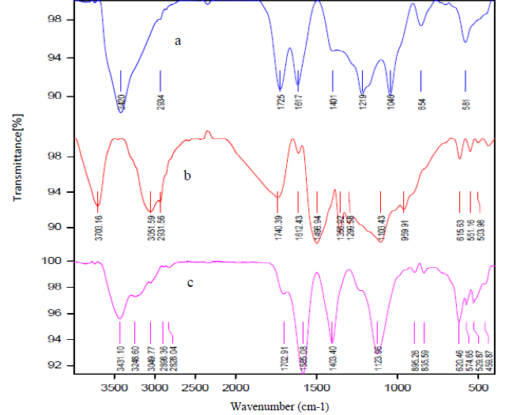
Fig.S1. FT-IR spectrum of A) Graphene oxide, B) Reduced graphene oxide, and C) AuNP-PRGO composite.

References:
22. Titelman GI, Gelman V, Bron S, Khalfin RL, Cohen Y, Bianco-Peled H. Characteristics and microstructure of aqueous colloidal dispersions of graphite oxide. Carbon N Y. 2005;43(3):641–9.
23. Yang C, Yu Y, Xie Y, Zhang D, Zeng P, Dong Y, et al. One-step synthesis of size-tunable gold nanoparticles/reduced graphene oxide nanocomposites using argon plasma and their applications in sensing and catalysis. Appl Surf Sci. 2019;473:83–90.
24. Darabdhara G, Das MR, Singh SP, Rengan AK, Szunerits S, Boukherroub R. Ag and Au nanoparticles/reduced graphene oxide composite materials: synthesis and application in diagnostics and therapeutics. Adv Colloid Interface Sci. 2019;271:101991.

